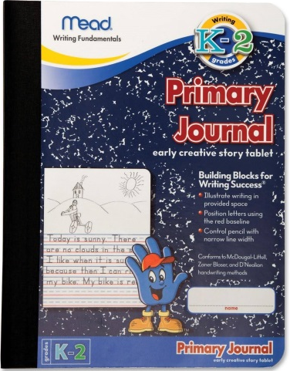
Kindergarten – 1 Primary Journal

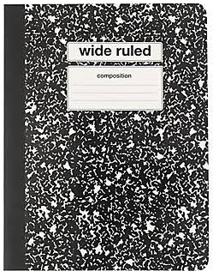
1st Grade and new ELL students – 1 composition journal

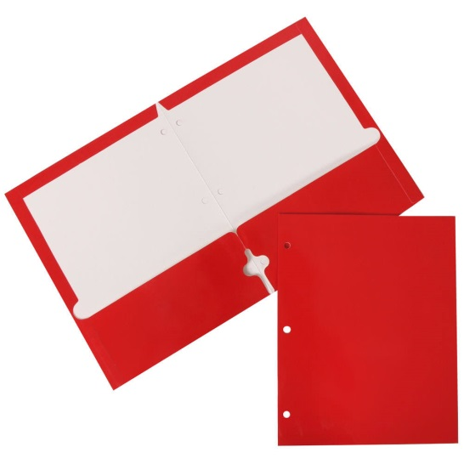
K-4 ELL students – 1 pocket folder
Kindergarten: red
1st grade: blue
2nd grade: yellow
3rd grade: green
4th grade: purple

Optional: pencil, tissues

